# OMAA logo

# OMAA 2025 Conference Program

## Theme: Independent and working together

Our conference aims are to empower every professional involved in Orientation and Mobility who are critical to quality of outcomes for the individuals at the heart of O&M, from O&M Specialists to others supporting service provision.

In the Orientation and Mobility field, work independently and together involves O&M Specialists working in different countries, but united as a unique profession, as Australasian professionals, members of OMAA, and those associated with us, supporting one another. Work together involves working collaboratively with clients, family, clients’ supports, team members and other professionals involved in vision rehabilitation services.

As we explore research, new ways of practice, emerging technologies for the future of the O&M profession we will enhance the profession as we move forward.

Conference dates: 14-15 March 2025

Conference Venue: Australian Hearing Hub, University Drive, Macquarie University (Sydney Australia)

Conference Accommodation: [Options available at this link](https://docs.google.com/document/d/1Uvmj5945_SH6eoE1x1Pq6ufI8zFHh8gX/edit?usp=sharing&ouid=117998067939240937747&rtpof=true&sd=true)

## 5-8pm Thursday 13 March: Welcome Cocktail Party

NextSense Central, 2 Gymnasium Road Macquarie University.

## Conference Day One: Friday 14 March 2024

|  |  |
| --- | --- |
| Time | Activity |
| 8:30am | Registration |
| 9am | Official welcome  Committee |
| 9:30 | Keynote 1  Daniel Kish |
| 10:30 | Morning Break |
| 11:00 | Session 1  Seeing Eye Dog Youth Program – innovation to empower young people  Brooke Anderson |
| 11:25 | Session 2  Understanding the Footpath challenges and the impact of losing traditional environmental design clues for people who are blind or have low vision.  Jennifer Moon |
| 11:50 | Session 3  O&M for rough terrain and bushwalking: some reflections from practice.  Nathan Burford |
| 12:15 | Session 4  Blending v-LIFE and O&M training to build self-confidence and self-determination for independent travel.  Mariagrazia Bellio, Lyndel Bosman, Jennifer Churchill, Rebecca Dunkley, Andrea Flew, Nicole Johnson, Claire Northrop, Fiona Ryan, and Karyn Willins |
| 12:40 | Session 5  Celebrating a collaboration: Three reflections regarding Orientation & Mobility (O&M) Student training in NSW  Lauren Baxter, Kay Daly, and Karen Carrigan |
| 1:05 | Lunch |
| 1:45 | Session 6  Wheelchairs and white canes: a technical aid alternative  Mael Fabien |
| 2:10 | Session 7  Exploring the feasibility of a robotic guide for people with low vision and blindness.  Doug Ritchie and Kelly Prentice |
| 2:35 | Session 8  Enhancing Independence: Training programs for O&M with bioptic telescopes  Dr Sharon Oberstein |
| 3: 00 | Session 9  Technology and innovation to enhance skills education in an O&M tertiary training program  Felicity Gates and Matthew Walker |
| 3:25 | Session 10  Friendly Trials – Codesigning O&M research to evaluate ARIA assistive technology  Dr Lil Deverell |
| 3: 50 | Afternoon Break |
| 4:15 | Retrospective – O&M in Australia and New Zealand over the last 25 years. Where have we come from and where are we now?  Nicola McDowell & Angela Reynolds |
| 4:45 | Final Comments inc. committee introductions  Committee |
| 5:00-6:00 | Program Close and OMAA Executive Meeting |
| 7pm | Conference Dinner (Verace Restaurant) |

## Conference Day Two: Saturday 15 March 2024

|  |  |
| --- | --- |
| Time | Activity |
| 8:30am | Registration |
| 9am | Welcome  Committee |
| 9:15 | Keynote 2  John Ravenscroft |
| 10:15 | CS1:  Girl from the Sticks, Surviving Sydney Sightless  Melanie Stephens |
| 10:30 | CS2:  Getting Somewhere or Going Anywhere: Developing Independence Beyond the Itinerant Model  Cass Embling |
| 10:45 | Morning Break |
| 11:15 | Session 11  Developments in Miniguide use with 4 wheeled walkers  Diana Grobler & Carina Lewis |
| 11:40 | Session 12  Haptic Social Signing  Alana Bogart |
| 12:05 | Session 13  Reaching the regions: Diversifying O&M support for children and adults with a vision impairment  Jessica McLeod, Brenda Harris, Jeremy Hill, Karen Drew, and Daniel Ellison |
| 12:30 | Session 14  Active modification of public spaces by people with visual impairments  Momoka Hirai |
| 12:55 | Lunch |
| 1:45 | Keynote 3  Ben and Tristan Clare |
| 2:30 | Session 15  Certification, Recertification and Advancing Professional Competency  Erica Ihrke |
| 2:55 | OMAA Call to Action  Committee |
| 3:30 | Closing Address and Final Comments  Kay Daly and Ewa Borkowski |
| 4:00 | Program Close |

With thanks to our sponsors:

 Quantum logo
 

## Map of OMAA Conference 2025 venue and surrounds

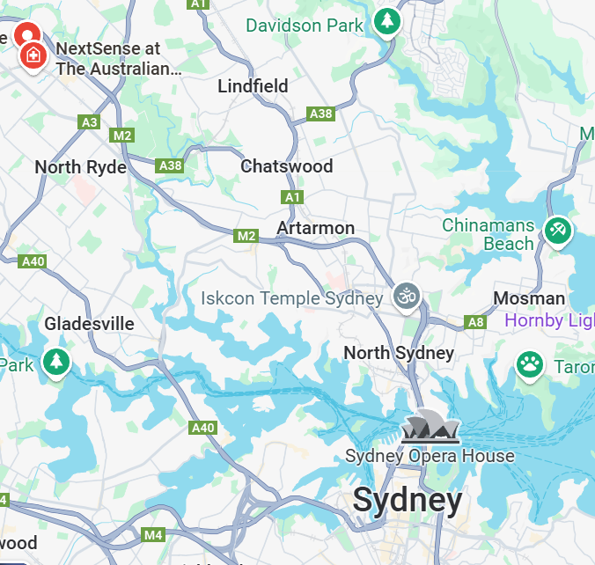

The Australian Hearing Hub, Macquarie University Campus:

16 University Avenue

Macquarie Park NSW 2109

Sydney CBD

# Transport

Catch train from Central Station to Macquarie University Metro Station (approximately 40 mins)

* Transport for NSW – click on Trip Planner: [Trip Planner](https://transportnsw.info/trip#/trip)  Phone: 131 500
* Metro option from the city – route Sydenham to Tallawong, click for metro website here: [Sydney Metro](https://transportnsw.info/travel-info/ways-to-get-around/metro?date=2024-11-25)

**Macquarie University Station** to Australian Hearing Hub (Conference Venue) – 10 minute walk.

# Local shops, services and attractions

**Macquarie Shopping centre**

Click here for website: [Macquarie Centre](https://www.macquariecentre.com.au/home/)

**Lane Cove National Park**

Click here for website: [Lane Cove National Park](https://www.nationalparks.nsw.gov.au/visit-a-park/parks/lane-cove-national-park) Provides a range of walks in beautiful bushland for all ranges of abilities and fitness. You could use: [NSW National Parks App](https://www.nationalparks.nsw.gov.au/app)

**Conference Venue location:**  The Australian Hearing Hub

Macquarie University Train Station

Accommodation options:

[Meriton Suites North Ryde](https://www.meritonsuites.com.au/our-hotels/nsw/northern-sydney/north-ryde/)

[Mercure Suites Motel](https://all.accor.com/hotel/B976/index.en.shtml?utm_campaign=seo+maps&utm_medium=seo+maps&utm_source=bing+maps)

[Holiday Inn Express Sydney Macquarie Park Motel](https://www.ihg.com/holidayinnexpress/hotels/us/en/sydney/sydmp/hoteldetail?cm_mmc=BingMaps-_-EX-_-AU-_-SYDMP)

[Hotel in Sydney, Australia | Courtyard Sydney-North Ryde](https://www.marriott.com/en-us/hotels/sydry-courtyard-sydney-north-ryde/overview/)

[Quest Macquarie Park Motel](https://www.questapartments.com.au/properties/nsw/macquarie-park/quest-macquarie-park)

[Nightcap at the Ranch Motel](https://nightcaphotels.com.au/hotels/nsw/nightcap-at-the-ranch)

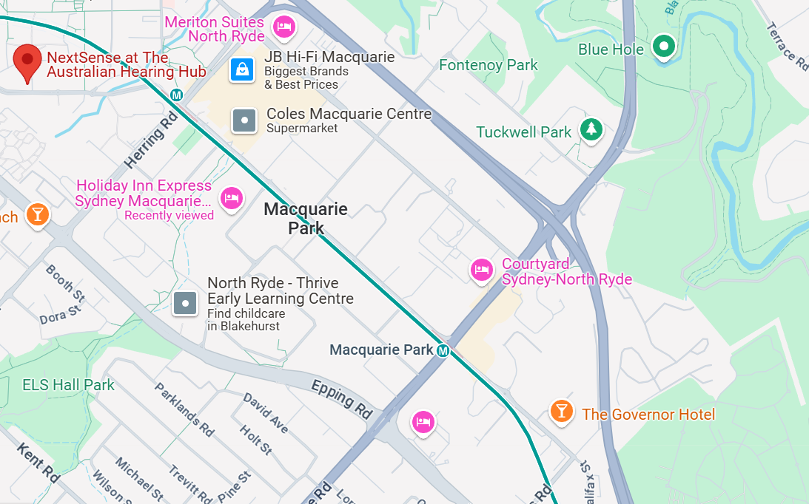

**Coctail Party location:** 2 Gymnasium Rd, Macquarie Park at [**NextSense**](https://www.mq.edu.au/about/locations/campus/current-projects/nextsense). They are located on the edge of the Macquarie University campus, just off the roundabout in Culloden Rd, 10 minute walk from Australian Hearing Hub.

**Dinner venue location:** [**Verace Pizzeria**](http://www.veracepizzeria.com.au)7 Khartoum Road, Macquarie Park.