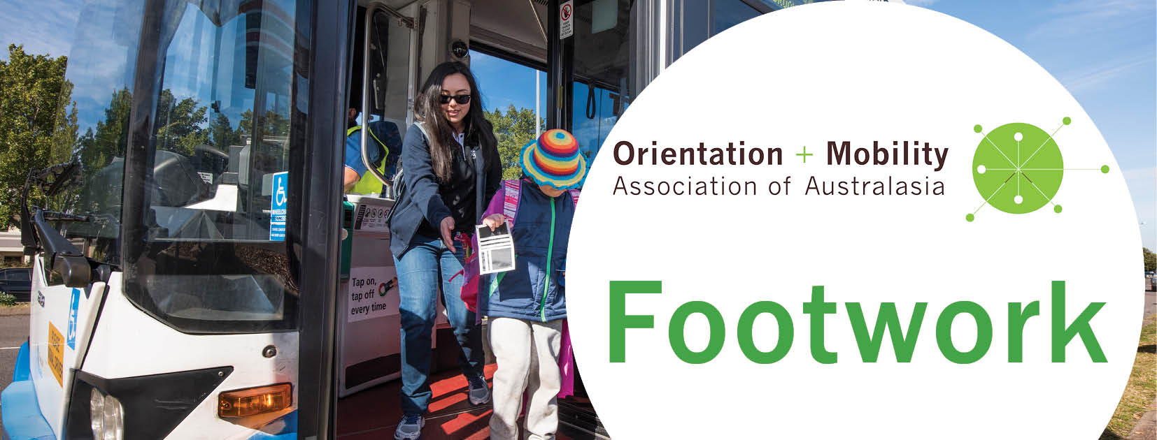
Issue 2, August 2018

Welcome to the second issue of Footwork, keeping you informed of developments in the Orientation and Mobility Association of Australasia (OMAA).

The Certified Orientation and Mobility Specialist (COMS) program is now open to Australian and New Zealand (ANZ) applicants
– Get your name on the list!
On June 1, the Academy for Certification of Vision Rehabilitation & Education Professionals (ACVREP) announced that its COMS program has been reopened to international applicants, with new ANZ-friendly eligibility criteria: https://www.acvrep.org/newsitem?id=51 These criteria create a great benchmark for our O&M training programs to meet, moving forward. But what about O&M specialists who are already qualified and working in the field?
You might read these new criteria and wonder whether you are eligible to apply for COMS, and if so, through which pathway? Fear not. If you meet the criteria as outlined in Category 1 or Category 2, either Path A or Path B, you may proceed to apply directly at any time. If you do not meet any of the pathways for eligibility, the OMAA has arranged to make a group submission to the ACVREP asking for exceptional consideration on behalf of Australian and New Zealand O&M professionals who indicate that they might want to apply for COMS in the next year.
In the group submission, the OMAA will explain how each O&M course has covered the required body of knowledge and how graduates have demonstrated their professional competence in the field. This saves ANZ applicants from having to explain these details individually. The ACVREP Board of Directors will review the group submission and let the OMAA know if exceptions have been granted. Then, if you have been granted the exception, when you are ready to apply, if you have not had a COMS-supervised internship, you will apply in Path B regardless of where you did your training. When the ACVREP receives your COMS application they will check your evidence and name against the list provided by the OMAA. Once you have been declared eligible you will follow the steps outlined on the ACVREP certification home page that will provide clear instructions.
The OMAA plans to send in the list and make the group submission to the ACVREP by the end of September 2018, so let us know your intentions. Check out the COMS handbook https://www.acvrep.org/certifications/coms. If you’re wondering about applying for COMS, but are unsure, then get your name on the list anyway. You can decide later whether or not to pursue your individual application to ACVREP. Simply email the omaasecretary@gmail.com with your name, contact details, the O&M course you completed, in which year, and put “COMS list” in the subject line.

COMS – It’s expensive, so why bother?
Since 1970, there have been at least 14 different O&M training programs in Australia and New Zealand (see page 4), with no consensus about standards for content or delivery. The industry has mostly relied on agency-employers to set the standards for training programs and professional practice, weeding out less capable workers. This agency self-regulation has relied on relationships, reputations, and recruitment being undertaken by qualified O&M specialists who are well-connected in the industry. However, the O&M industry has grown, and recruitment is now often undertaken by HR specialists and managers who don’t necessarily have an O&M background or established O&M networks. The Australian and New Zealand industry also recruits O&M personnel from overseas. We can’t rely on people knowing people for quality control in the profession. We need an independent benchmark to measure the competence of O&M specialists.
Becoming a COMS means adopting a common, recognisable international standard for professional practice that enables workers to be publicly recognised and move between employers. The COMS program also provides international standards for our Australasian O&M training programs and for continuous professional development. The ACVREP is committed to making COMS internationally accessible.

COMS – Who needs it?
Certification of O&M specialists is an important step in establishing O&M as a self-regulating profession and gaining recognition for the O&M profession and O&M professionals from governments and other professional bodies (e.g. ability to register as an NDIS provider). The model on page 3 shows the process.
In short, the OMAA encourages every O&M specialist working in the field to apply for certification. We need critical mass. Individual O&M specialists need to become certified and registered with the OMAA, so that the OMAA can apply for the recognition of the O&M profession, and the OMAA can be recognised as the relevant self-governing professional body with government agencies like the National Disability Insurance Authority (NDIA) and the NDIS Quality and Safeguards Commission. We need O&M employers to support this process, but they cannot do it for us – it needs the commitment of individual O&M specialists working in conjunction with the OMAA.

Inclusion as a self-governing profession, able to register in the NDIS Provider Guide to Suitability, would also allow registered NDIS providers to practice as sole traders. This requires the OMAA to be a professional peak body that provides appropriate governance and regulation of the profession. The OMAA has also identified certification/registration as a priority for O&M specialists:
- in OMAA leadership roles
- teaching tertiary O&M programs, supporting O&M graduates to register
- supervising students in placements and internships
- in team leader roles, overseeing staff professional development
- working in isolated areas with minimal supervision

COMS webinars
The OMAA is offering four videoconferences during August to deal with questions about COMS. You can join one of these conversations by clicking on the link below. You don’t need to RSVP. Alternatively, you can contact lil@deverell.net to arrange a separate videoconference for you and your team. This invitation is extended to CEOs and managers, not just O&M specialists.
Thursday 9 August @ 10am https://swinburne.zoom.us/j/809153721
Thursday 9 August @ 2pm https://swinburne.zoom.us/j/461754482
Monday 13 August @10am https://swinburne.zoom.us/j/334960703
Monday 13 August @ 2pm https://swinburne.zoom.us/j/494327565

Which O&M training program did you do?
The OMAA has been putting together a list of all the O&M courses offered in ANZ, but we need your help to make it accurate before we send it to the ACVREP. Could you please check your certificate or testamur and send us a scan attached to an email? We also need to know how many hours of internship you did (if any) and how this was managed in relation to your course. Please help us to fill in the blanks with evidence.
Years | Provider | Qualification | 350 hour Internship
1971 -1991 | RGDAA | Graduate diploma (1987)
1987? | Victoria College | Bachelor of Arts – Disability Studies (O&M)
1992-? | La Trobe Uni | Graduate Diploma in O&M | Not included in course.
? | La Trobe Uni | Bachelor of Health Sciences (O&M)
2008- 2011 | La Trobe Uni | Graduate Diploma in O&M | Not included
2000?- | Uni of Newcastle, Renwick Centre | Master of Special Education (Sensory Impairment) | Included
2003? | Flinders Uni | Master of Special Education (O&M)  Grad Cert in Disability Studies (VI)  Grad Cert in Education (O&M)
1998-? | Griffith Uni | Master of Human Services (O&M)
1989-2006 | Massey Uni | Graduate Diploma Rehabilitation (VI)
2007- | Massey Uni | Post Graduate Diploma Specialist Teaching (Blind and Low Vision, Developmental O&M)
2002-2006 | RVIB/VA | Certificate IV in Vision Impairment
2007-2014 | Vision Australia | Graduate Certificate in Vision Impairment
2016- | Vision Australia | Graduate Diploma in Vision Impairment | Included
2017- | Blind Foundation | Level 7 Diploma in Vision Habilitiation/Rehabilitation | Included

O&M Assistants
An O&M specialist is responsible for assessing the client’s mobility needs, then tailoring an appropriate program with/for the client, drawing on the full O&M skillset. The O&M specialist then determines how an O&M assistant can support this program, while the O&M specialist remains accountable for the outcomes.
O&M specialists often recruit the client’s family members, friends, teachers, aides and even local shop owners to serve as an O&M assistant. Vision Australia is currently training Occupational Therapists to serve as O&M assistants. During the 1990s, the RSB in Adelaide offered a nationally accredited Certificate III training package for O&M assistants. Limited O&M training is included in some university special education programs so that teachers can support O&M programs.
An O&M assistant, whether volunteer or professional, makes a valuable contribution in supporting clients’ mobility training. However, an O&M assistant is not a fully qualified O&M specialist. Certification of O&M specialists helps to maintain this distinction. The COMS exam benchmarks entry-level (first job) standards that O&M specialists must meet to ensure that the O&M body of knowledge and professional skill-set are not eroded over time.

Union Representation
The OMAA has recently received queries regarding union representation for its membership, from members and organisations alike. We are currently working together on an OMAA definition of O&M and Scope of Practice, but in the meantime:
the working definition for O&M, adopted by OMAA Executive, states that the profession teaches knowledge, concepts and skills to people of all ages who have low vision and blindness to understand, engage and move safely and efficiently in their environments drawing on a wide theoretical base. It is a unique and specialised profession that sits somewhere between the allied health/disability sector, education sector and to a lesser degree design (assistive technology, environmental access etc.). O&M is fundamentally educational, holistic and person-centred, building knowledge and capacity with the client. O&M specialists in Australasia do not operate from a medical deficit paradigm, seeing the client as damaged goods that need fixing but as agents of change and transformation. O&M specialists do not restore a clients’ vision or enable them to do what they did before they lost vision. Rather, as teachers, they assess what clients can do, identify their goals and what they are ready to learn next, then teach the necessary skills to move forward to achieve these goals, always recognising the messiness of client’s lives.
This definition clearly identifies that O&M lies somewhere between the allied health and education sectors. Not all our members have undergraduate degrees in allied health subjects, so it is not possible to align ourselves with the Allied Health Professional’s Union. It has been agreed by the Executive however, that we could align ourselves with the Independent Education Union (IEU). The IEU has agreed to accept OMAA members as part of their union and to act to support them in any negotiations. As an Executive of the OMAA we therefore accept and recognise IEU as the preferred union for our members.
We hope this motion made by the OMAA will now make it easier for negotiations to take place between OMAA members and their employing organisations.

You are welcome to circulate Footwork to anyone who might be interested. If you have queries about the work of OMAA, or would like to subscribe or unsubscribe to Footwork, please contact the omaasecretary@gmail.com
Lil Deverell, COMS PhD
Orientation and Mobility Association of Australasia

