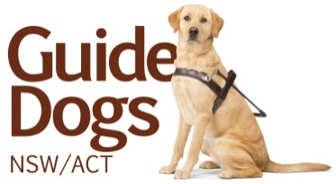

Master Degree Sponsorship for Orientation & Mobility Instructors

2016 Sponsorships
  - Opportunities for university graduates

Interviews to be conducted between 30 November 2015 to 9 December 2015 in the regions:
- Sydney
- Newcastle & Central Coast (interviews to take place in Sydney)
- Coffs Harbour & Tamworth (interviews to take place in Coffs Harbour)
- Canberra
- Albury (interviews to take place in Canberra)
- Orange

Guide Dogs NSW/ACT invites suitably qualified and interested applicants to be considered for sponsorship to undertake a Master of Special Education (Sensory Disability) through the RIDBC Renwick Centre, Sydney, a program administered by the Royal Institute for Deaf and Blind Children (RIDBC) and affiliated with the University of Newcastle.

Our sponsorship program is the first step toward launching your career as an Orientation & Mobility Instructor with Guide Dogs NSW/ACT. Selected candidates for sponsorship must successfully complete the first semester of the Master degree program (full-time) in 2016 and with all other employment criteria met, this may lead to an offer of full-time employment as an Orientation & Mobility Instructor from July 2016. Subsequent semesters of the Master program will be completed part-time by distance education/block release and/or online while employed full-time.

All course fees are covered as part of your sponsorship by Guide Dogs NSW/ACT.

Prior to submitting your application for these opportunities, interested applicants must ensure they meet the entry requirements of the RIDBC Renwick Centre, University of Newcastle. Enquiries about this program and the entry requirements are to be made in the first instance to Claire Farrington on (02) 9872 0811 / claire.farrington@ridbc.org.au.

Once academic suitability has been confirmed by the RIDBC Renwick Centre, your application may be forwarded via email to: jobs@guidedogs.com.au quoting the Master Degree Sponsorship opportunity. There are strict requirements for applications including:
- Your current CV inclusive of how you meet the essential criteria for sponsorship and the contact details of two professional referees (not exceeding 2 pages); and
- A written response to the following question (between 250-300 words): “Why are you applying for this opportunity?”

Where you do not meet these application requirements your application may be rejected.

For more information please see the Information Pack on our website at http://www.guidedogs.com.au/contact-us/employment-opportunities/positions-vacant

Applications close: 12 November 2015

For further information about the role of an Orientation & Mobility Instructor contact Sonya Leotta on (02) 9412 9373.

